Dundee Middle School
6th and 8th Grade Band Handbook
2014-2015

Dear Parents and Students,

Welcome to a new school year in the District 300 Instrumental Music Program. The purpose of this letter is to inform and advise you about some of the district 300 Instrumental music policies. This information should help make your child’s musical experiences at DMS both successful and enjoyable.

THE PERFORMANCE SCHEDULE IS ON THE BACK OF THIS PAGE. PLEASE KEEP THIS SCHEDULE AND MARK THE DATES ON YOUR CALENDAR NOW.

At various times during the year, I may need assistance with activities. If you are interested, please note your availability on the handbook form. I will then contact you about specific events. Your help and support is the key to maintaining an outstanding band program and I appreciate your help.

My goal is to provide your child with the best instrumental music education possible. If you have any concerns or questions about your child’s participation in the band program, please contact me at 224-484-4537 or by email at kathleen.way@d300.org. Please note that the DMS Music Department has its own web site on the DMS home page which will be updated regularly

Thank you for your encouragement in your child’s enrollment in music. Statistics indicate that if your child participates in music, he or she is likely to earn higher grades and score better on standardized tests. There is powerful scientific evidence of a cause and effect link between music instruction and intelligence. Please sign the handbook contract on the last page informing us of your commitment to your child’s participation in the Dundee Middle School Band. Your child will begin the year by receiving a quiz grade of 100% for returning the signed form by Wednesday, August 21st.

Sincerely,

Mrs. Kathleen Way
6th and 8th Grade Band Director
Music Team Leader
DMS Band Calendar 2014-2015
** Items marked with stars are required performances

Saturday - October 4, 2014 ILMEA Jr. Auditions at Yorkville Middle School
Audition times TBA: between 8:00AM-1:00 PM
(Only for students who wish to audition)

Saturday - November 8, 2014 ILMEA Jr. Festival at Metea Valley High School
(Based on results from auditions)
Concert Performance at 3:00 PM

Wednesday – November 12, 2014 ** DMS Fall Band Concert
Dundee Middle School Gymnasium
7:00 PM (Students arrive at 6:15 PM)

Tuesday - January 13, 2015 District 300 Honors Band Concert
Location: Algonquin Middle School
7:00 PM (Select Student Participation)

Wednesday – February 25th, 2015 ** DMS Winter Band Concert
Dundee Middle School Gymnasium
7:00 PM (Students arrive at 6:15 PM)

Saturday - April 11, 2015 District 300 Solo & Ensemble Contest
Dundee-Crown High School
Various assigned times between 8:00 AM – 12:00 PM

Monday – May 11, 2015 ** DMS 6th grade Band Concert/combined with 5th grade feeders
Dundee Middle School Gymnasium
7:00 PM (Students arrive at 6:30 PM)

Wednesday - May 13, 2015 ** DMS Spring Jazz, 7th and 8th grade Band Concert
Dundee Middle School Gymnasium
7:00 PM (Students arrive at 6:15 PM)

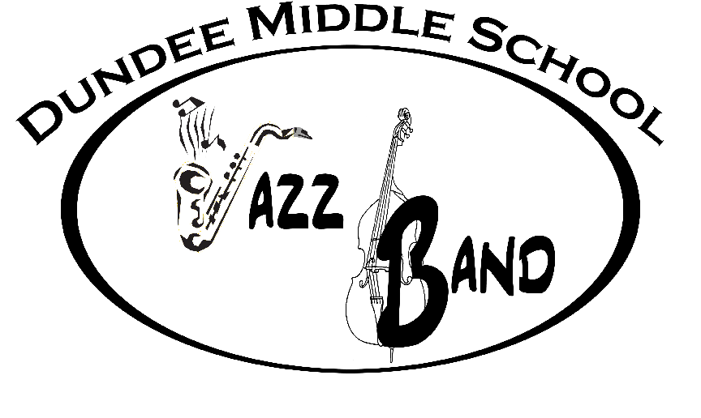
*** Please Note ***
Jazz Band will have more performances than what is listed above.

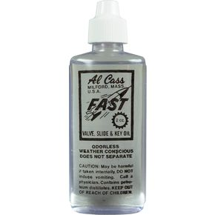
Band Supplies & Materials:

Students must bring to band:
- Their instrument (with name on case)
- A black three ring binder (no larger than ½ inch thick)
- A pencil that can be kept inside the band folder. You must have a pencil daily!
- Working reeds, cork grease, valve oil, etc. (if applicable)
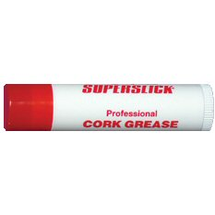
Percussionists must provide their own sticks.

Band Uniforms:

All band students will be required to wear the designated band uniform to concerts and other performances as directed. Uniform requirements will be:

Girls: Boys:

White Blouse White Button Down Shirt
Black Dress Pants or Long Black Skirt Black Dress Pants
Black Dress Socks Black Dress Socks
Black Dress Shoes (no heels or open toes) Black Dress Shoes

8th grade band members must wear white button down/long sleeved shirts or blouses.
They will also wear a red band vest provided by DMS.

Required Performances:

As this is a performance-based class, attendance at all performances is mandatory. The dates and places are in this handbook. Please put these dates on your calendar now so that you can schedule around them. If a student has to miss a performance, for any reason, they are to notify the director at least two weeks in advance using the Absent Request Form attached. (It is also available on the Music Web Site.) Why is attendance mandatory at performances?

*Performing for an audience is the primary focus of this class. Concerts provide an experience that cannot be reproduced in the classroom.

*Performances are the means by which the skills learned in class are evaluated.

*Band is a group effort. The performance is weakened by every missing instrument voice. We rehearse together and we perform together.
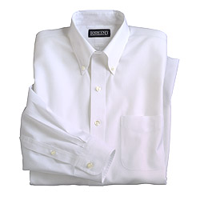
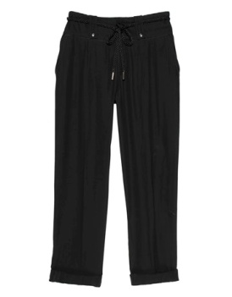

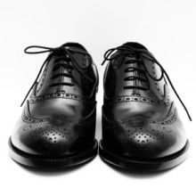

Extracurricular:

Participation in the activities listed below is not required, but students are greatly encouraged to audition for or join one or more of them. Before-school study sessions and/or rehearsals are required in most cases.

- Solo & Ensemble: This event is for students being adjudicated as a soloist or as part of a small ensemble.

- D300 Honors Band Festival: This band is made up of students selected to represent each middle school in the district.

- Jazz Band: This band is made up of 7th and 8th grade students interested in learning and performing in the styles of jazz, rock, funk, fusion, swing, etc. This group generally has a few outside performances that are determined throughout the jazz season. Placement in the jazz band is based on audition and instrumentation. Mr. Bishop is the Jazz band director.

Procedures & Routines:

*Be on time in your assigned seat when class begins.
*Participate in all classroom activities – especially playing!
*Be prepared! Have your instrument, music binder, and pencil with you for every class.
*No GUM, food, or drink is allowed. This is not only a band expectation, but a school policy.

Absences from concerts / performances:

Concerts are an integral part of any band program. There is no way to make up the experience if a concert is missed. Students are expected to attend *ALL* performances. All concert dates are provided early in the year so that families can avoid scheduling any conflicting appointments or trips around those dates. Excused absences: Illness; death in the family; other emergency situations; pre-arranged absences (i.e. religious reasons) where Absence Request Form is received at least two weeks prior to the concert. *In order to receive a passing grade for the concert, a student will be required to complete a makeup assignment and a grade will be issued based on quality of assignment.

Ensemble Behavior:

Our band ensembles are essentially music teams. The actions of any individual can either help or hinder the entire ensemble in both rehearsal and performance. Self-discipline is not optional; it is required. Repeat offenders will conference with the director and may be removed. A point system will be used to promote proper ensemble behavior. Students will lose participation points for any infraction in the following areas:

- Class preparation • Sitting in correct seat and quiet when class begins
- Quiet during rehearsal when not playing • Demonstrates correct posture while playing
- No Gum, Food, Drink, or Cell Phone • Respect for self and others
- Respect the room and property within it • Participates appropriately during rehearsal

Grading Policy:

Grades are earned by assessing each student’s knowledge (classroom assignments, quizzes, and exams), skills (chair placement assessments), and participation in daily rehearsals and required performances. Grades will be assessed on a weighted point system as follows:

35% Daily Preparation/Class Participation
Students are expected to be prepared for class with the correct materials. They are also expected to participate in class with a positive attitude with their best effort.

25% Concert Attendance
Students are required to attend ALL performances during the school year. Band is a performance-based class, and it is mandatory that students attend all concerts. If there are any problems, parents need to contact me two weeks in advance. If there in an excused absence from a concert, the student will be given an alternate assignment. All students are expected to stay for the entire concert in order to receive all points for the event. Part of the learning experience entails hearing the other grade level bands. If a conflict arises and a student must leave before the end of the concert, I will need a written note from a parent prior to the start of the performances.

15% Performance Assessments
Band is a performance based class. Students will be evaluated formally and informally throughout the year during small group lessons and full band rehearsals in order to assess growth in skill level and proficiency of assigned material. These assessments will include, but are not limited to: scales, rhythm examples, sight-reading passages, specific sections of concert music, etc. The best way for a teacher to tell if a student is practicing correctly, is by using basic performance assessments. These assessments will replace written practice logs.

15% Lessons
Students will have the opportunity for a small group lesson once each week. The lesson schedule will be rotated so that students are not always missing the same class. This is a great opportunity for students to work on specific aspects of their instrument or parts of band repertoire that are problem areas. Attendance and participation during these band pull-out lessons is extremely beneficial to each student and mandatory. It is the student’s responsibility to make each pull-out lesson. You will be excused from your lesson if you have a test or review in that class or you are absent from school during that period.

10% Assignments/Written Work
Written work is minimal in band. All newsletters sent home will have a sign-off portion on the bottom. Students and parents are to read these newsletters and return the signed portion in the allotted time frame. This is to ensure that parents receive important information.

Extra Credit Non-DMS Concert Attendance
Students will have the opportunity to do a report on one concert every quarter for extra credit (please attend more if you can!) The concert must be approved by Mrs. Way before credit will be given.
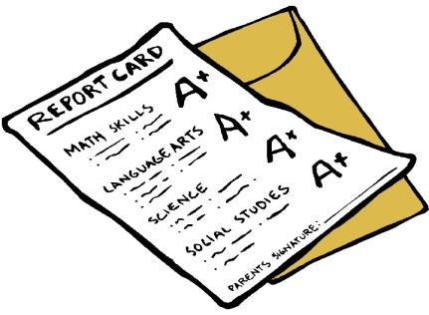

Dundee Middle School 6th and 8th Grade Band
PARENT/STUDENT HANDBOOK CONFIRMATION FORM
2014-2015
Due by
Thursday,
Aug. 21st!
This is worth a 100% quiz grade!

To be signed by parent and student!

PLEASE SIGN AND RETURN THIS PAGE ONLY

The intent of this form is to verify that band parents and students understand and agree with what is involved with membership in the Dundee Middle School Band Program.

PLEASE CHECK BOXES BELOW:

- I have read the DUNDEE MIDDLE SCHOOL 6th and 8th GRADE BAND HANDBOOK including the grading policy with my child and we understand our responsibilities in maintaining a successful band program.
- I understand the concert attendance and uniform requirements as stated in the handbook.
- I have taken the time to mark down the band concert dates.
- I give permission for photos and/or videos to be used for music department purposes.

__________________________________________ _____________ _____________

Student Name (Please Print) Grade Instrument

Parent A: | Parent B (if applicable)
*Name: __________________________________________  *Email ___________________________________________  Cell Ph: __________________________________________  Home Ph: ________________________________________  I may be available to chaperone field trips or volunteer at these times: (check all that apply)  Daytime Evenings Weekends Anytime | Name: ___________________________________________  *Email ___________________________________________  Cell Ph: __________________________________________  Home Ph: ________________________________________  I may be available to chaperone field trips or volunteer at these times: (check all that apply)  Daytime Evenings Weekends Anytime

X____________________________________ ____________________

Parent Signature Date

X____________________________________ ____________________

Student Signature Date

